**The Project**

1. Build a simple ETL process to digest the provided set of .csv files into an OLTP schema as shown in the ERD diagram below. The create scripts for this schema are also available to accelerate this process.

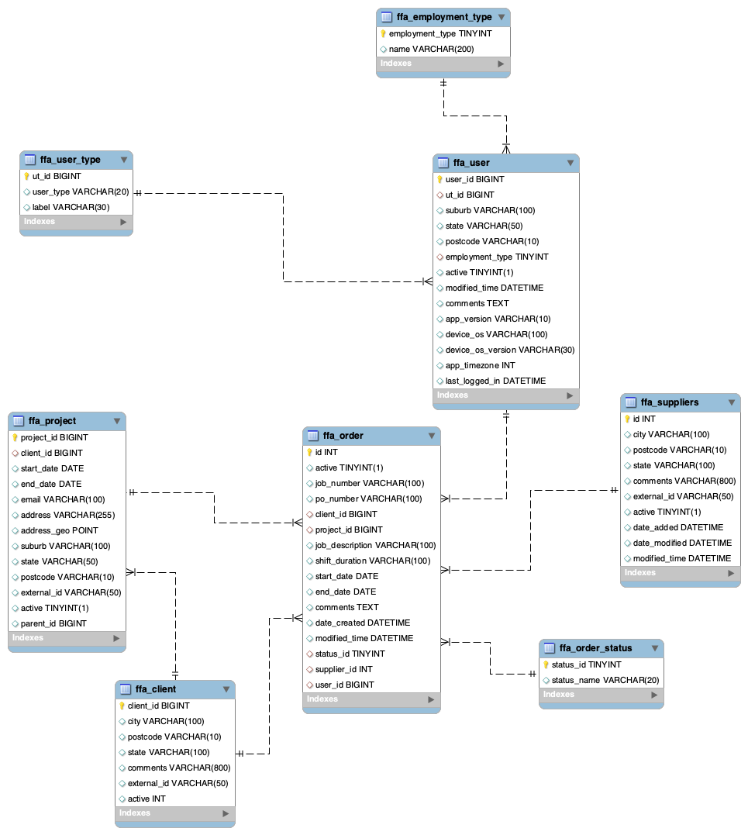

1. Convert this OLTP database structure to OLAP(Star/Snowflake) database structure for BI/Reporting purpose. You can design the ERD using a tool or just by pen and paper.
2. Load the data from OLTP schema to OLAP schema.
3. Using OLAP Schema please answer the following questions by writing SQL queries.
   1. How many Dashboard users have created orders in the year of 2020.
   2. Which project has been worked on the longest.
   3. Which client has the largest Quarter over Quarter growth (number of orders they have completed) in 2020?
4. How would you design the load scripts if the frequency of processing changed from batch to real time?
5. How and what kind of monitoring systems would you set up to make sure the data is correct, accurate and available in a timely manner.

Bonus Points : If the above project is set up on AWS environment.

### **Tools and Technologies**

We would like you to use Python and SQL, as these are our everyday tools.

However, we are open to other open-source tools and technologies, if we are able to easily replicate on our side.

## **What we need from you?**

Build your ETL process and send us the code with your answers in the email.

#### **Expectations**

* Include a step-by-step instruction to run your code.
* You are expected to be able to explain this whole process in a face-to-face interview.
* Allow for 4 hours for this test.